Goal:
The goal of a DERAGGER™ anti-ragging device product demo is to allow the customer to discover the functionality and money-saving capacity of efficient DERAGGER™ technology first-hand. If the customer is happy with the device, they should keep it and consider applying the technology wherever it can benefit them in their system.
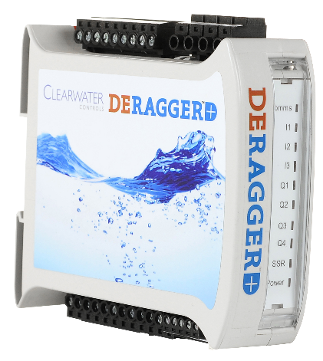
Requirements:
The DERAGGER can be applied to any rotating equipment, but typically is used on Centrifugal Pumps, Mixers, and Surface Aeration equipment. Generally the DERAGGER™ is used with three phase motors up to 600v (UL listing is to 600v), although in certain circumstances can be applied with single phase motors, or motor voltages in excess of 600 volts (contact DERAGGER™ Technical Support for these applications). There must be a method to reverse the motor in place, a VFD can simply be sent a reverse command, but across-the-line installations require a reversing contactor. Soft Starts are sometimes reversible, if not, a reversing contactor is required. Page 2 of this document is an Application Data Sheet, with the info needed to make sure the demo install goes as smoothly as possible.
Process:
Generally demos run for either 30 or 60 days, and the customer has the option to run the demo one of two ways:
- Immediate: The Anti-Ragging App can be enabled at commissioning, and the immediate benefit of no longer having to pull clogged equipment will show a considerable savings in the reduction of man-hours used to clean said equipment.
- Before & After: The Anti-Ragging App can be enabled halfway through the demo, and the first half of the demo will be a “data gathering” period where the unit’s built-in Datalogger can establish a “before” baseline of power consumption and runtime, and also calculate the energy saving during the “after” period once the Anti-Ragging App is enabled. This allows for a more accurate calculation of savings from increased efficiency.
The local distributor will check in with the customer, 1 week into demo to confirm everything is operating as designed and no additional tuning is required. Should any additional tuning be necessary this is available at no cost via DERAGGER Inc’s phone support.
Moving Forward:
Once the demo is complete, should the customer be happy with their lower operational costs and increased efficiency, it is requested that they purchase the unit from the distributor. If for some reason the unit did not perform as designed, the distributor shall take the unit back with no costs incurred to the customer other than those for installation.

(Please fill in the form below or fill out online at: www.deragger.com/ADS.)

Contact Information
Name:
Address:
Phone Number:
Email Address:
Site/Application Information
Site Address:
Equipment Quantity & Type (Pump, Mixer, etc):
Manufacturer/Model Number:
Power: | kW/HP Rating:________ Motor FLA: ________
Control Voltage: | 120-240 VAC: ☐ 24 VDC: ☐
Line Voltage: | Voltage:________ 3 Phase? Y/N Starter Type: ________

Current Situation. Maintenance and Energy
How often per month does the pump get clogged?
How long does it take to clean the pump?
How many employees are required to safely clean the pump?
How long does it take to access this location for a call-out?
What is the current hourly run-time per month for this pump?
What is the Electrical Utility cost to operate this station per month?
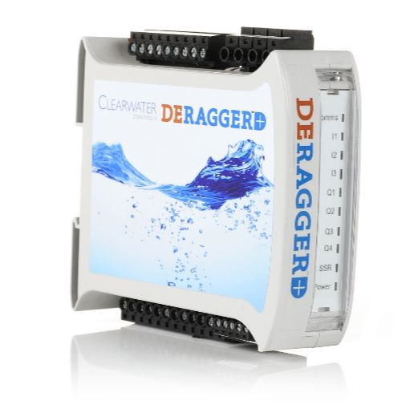
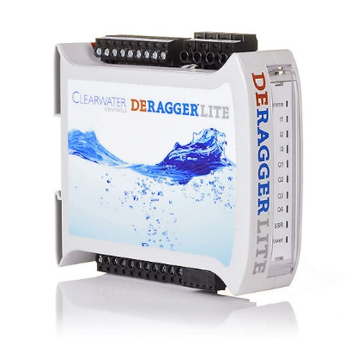
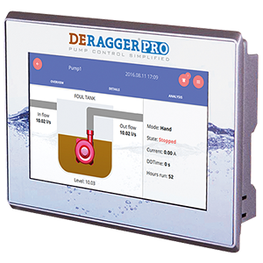

www.deragger.com/

